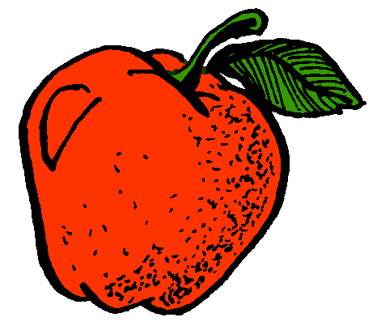  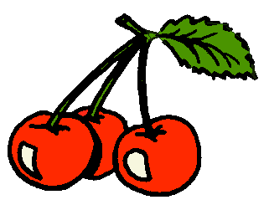 | 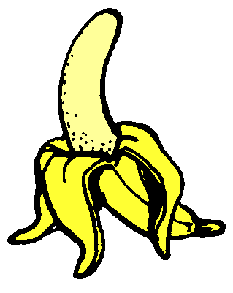 | 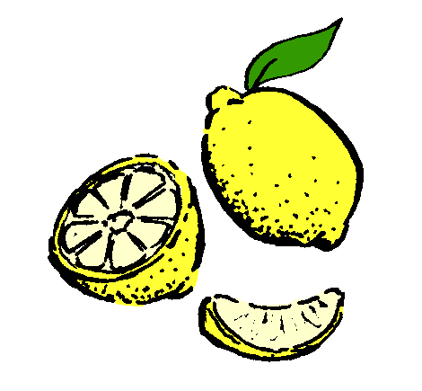
cherry |  |  |  |  | banana |  |  |  |  | lemon
 |  |  |  |  | 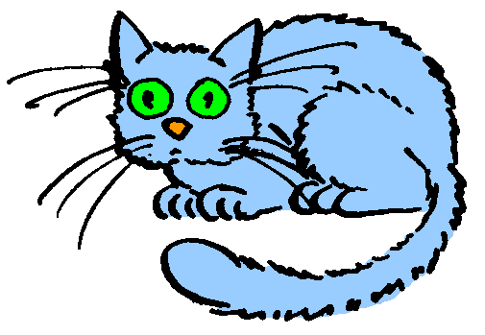 | 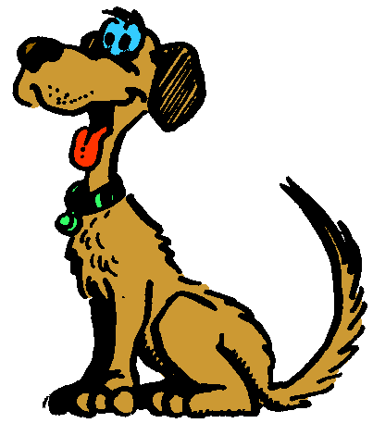  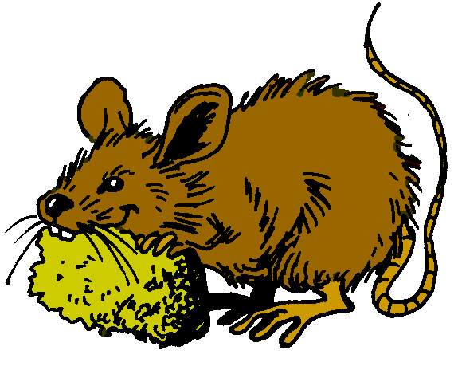 |  | 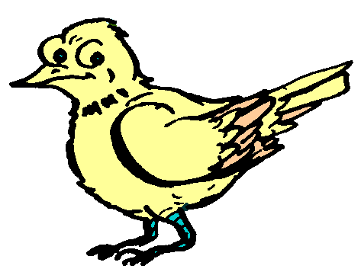
apple |  |  |  |  | cat |  |  |  |  | dog
 |  |  |  |  |  |  |  |  |  | 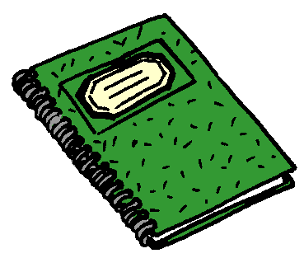 | 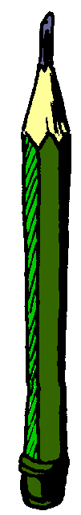 | 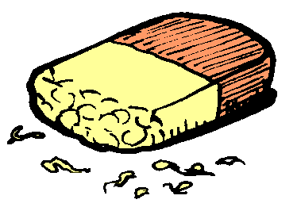 | 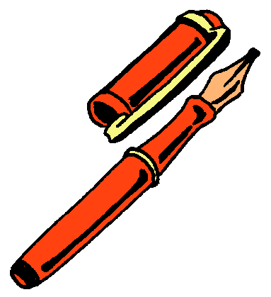
mouse |  |  |  |  | bird |  |  |  |  | pen / fountain pen

notebook |  |  |  |  | pencil |  |  |  |  | an eraser / a rubber
triangle |  |  |  |  | circle |  |  |  |  | rectangle
square |  |  |  |  | yellow |  |  |  |  | red

 |  |  |  |  |  |  |  |  |  | 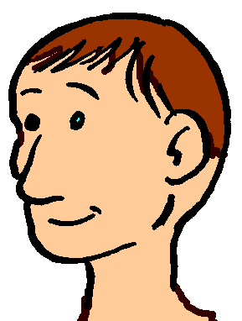 | 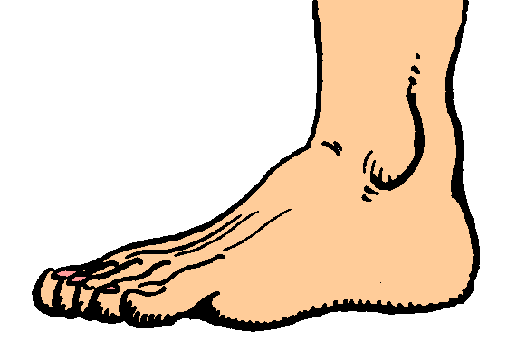 | 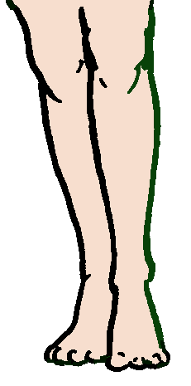 | 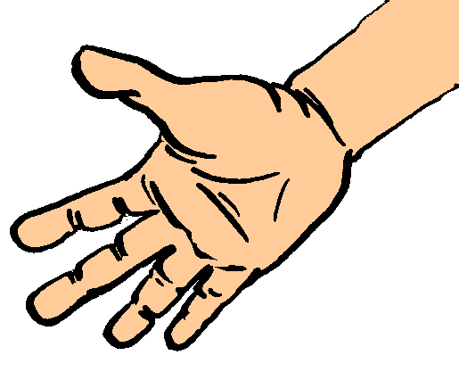
green |  |  |  |  | blue |  |  |  |  | head
a foot / the feet |  |  |  |  | a leg / the legs |  |  |  |  | hand
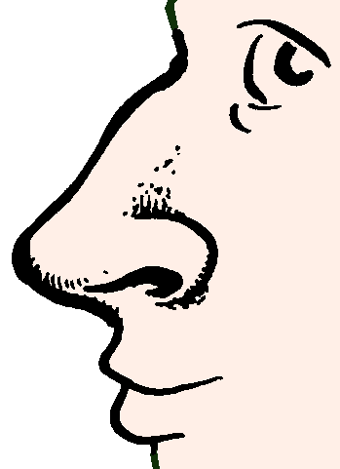 | 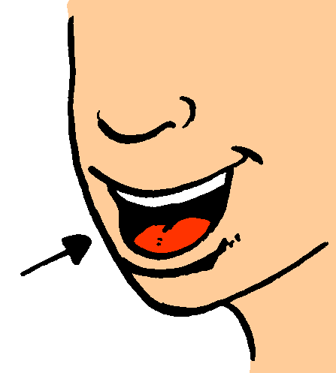 | 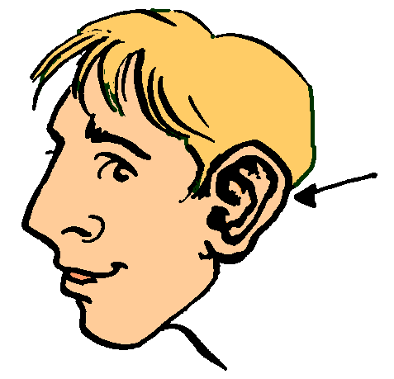 | 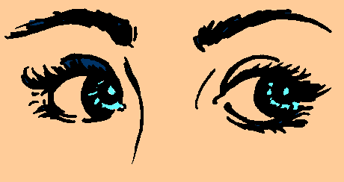
ear |  |  |  |  | mouth |  |  |  |  | nose

 |  |  |  |  | 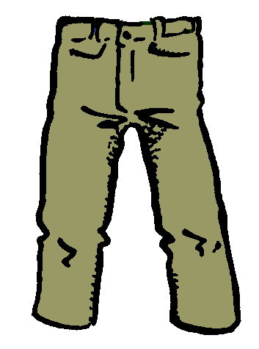 | 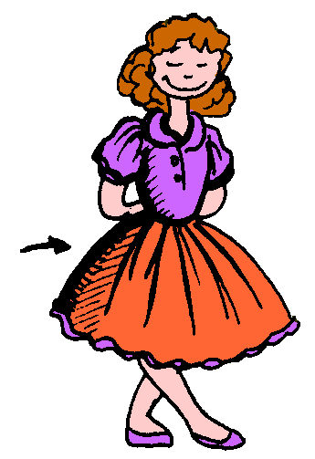 | 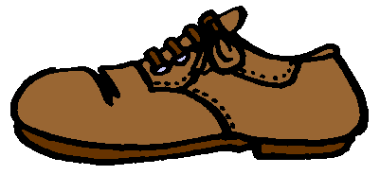 | 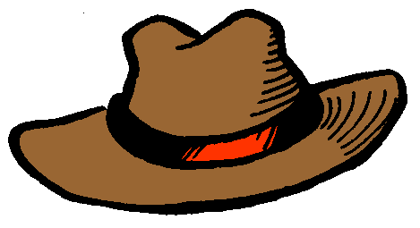
the eyes |  |  |  |  | trousers |  |  |  |  | dress
 |  |  |  |  |  |  |  |  |  | 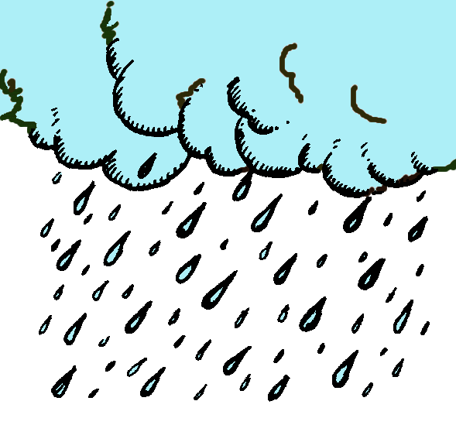 | 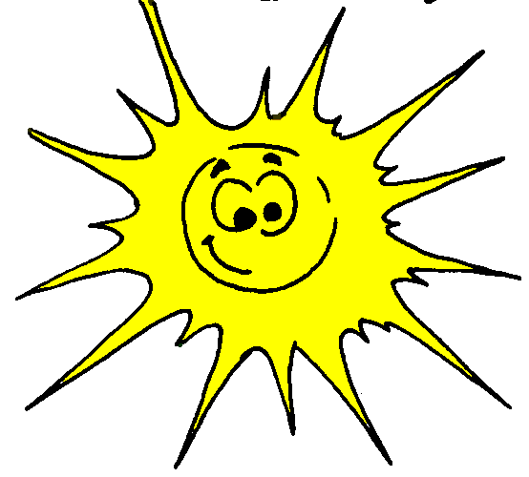 | 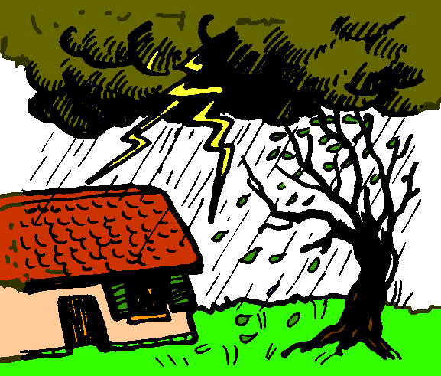 | 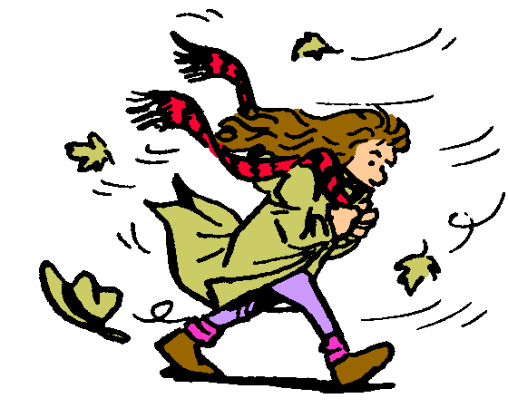
a shoe / the shoes |  |  |  |  | hat |  |  |  |  | rain
sun |  |  |  |  | storm |  |  |  |  | wind

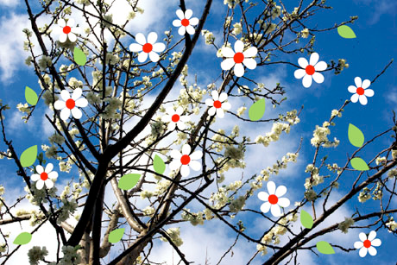 | 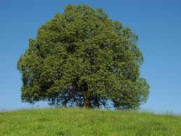 | 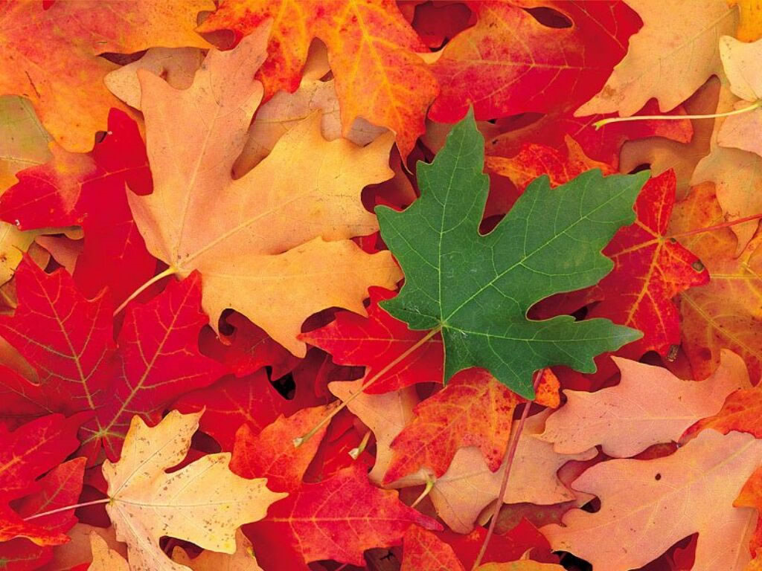 | 
spring |  |  |  |  | summer |  |  |  |  | autumn
 |  |  |  |  | 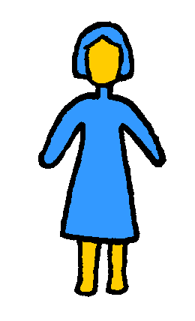 | 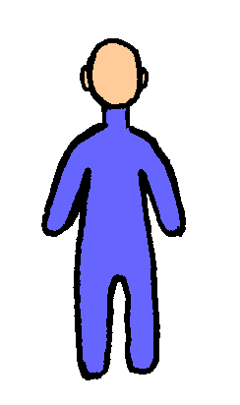 | 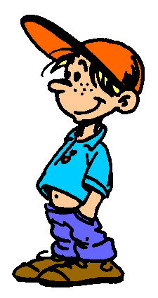 | 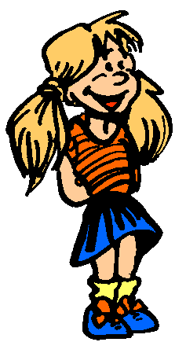
winter |  |  |  |  | brother |  |  |  |  | sister
mother |  |  |  |  | father |  |  |  |  | boy

woman |  |  |  |  | man |  |  |  |  | girl

